FAQ / Application Note
Subject : How to restore Android 8.1
FAQ Document No: | Date: 2020/10/19
Model Name: Generic | Rev. A2
Category: □General □H/W ■S/W □Others, Android
Purpose:
How to use an USB key to recover Android 8.1 OS for Avalue panel PC

Environment:
- System Model:
- BIOS version:
- Software Tool: Universal USB Installer (Download)
- USB Stick: 2GB or larger USB key
- Android 8.1 image file: 8.1-r5-rc7_userdebug_android_x86_64
(Please contact Avalue AE to get the image if necessary)

The recovery process includes two actions:

- To create an Android-x64 USB installer
- Install Android-x64 with USB installer
(1) To create Android-x86 USB installer
- Plug-In your USB disk into you PC and Run Universal USB Installer setup program.
- Follow the step to select the setting as below:
- Step 1: Android
- Step 2: Mark [Show All ISOs?] then click [Browse] to select the image .iso file
- Step 3: Select the correct Drive (USB disk) and tick the “Fat32 Format Drive”
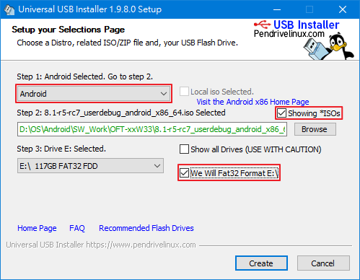

- Click <Create> to start the USB Installer setup process, the program will pop up a warning message, click <Yes> to continue the process.
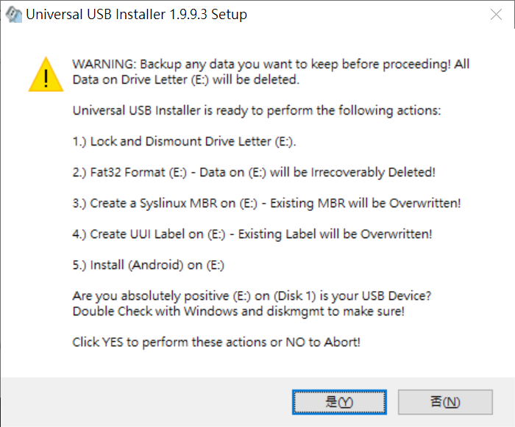
- After the process is completed, click <Close> to close this process.
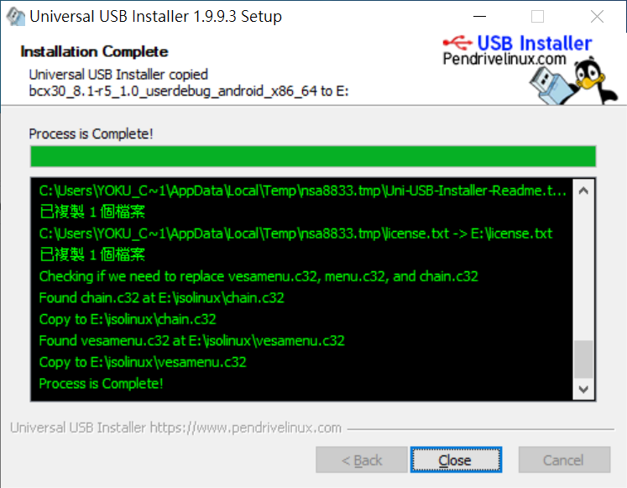
- When your system boot from this USB disk, it will start the Android-x86 install process automatic.

(2) Deploy Android-x86 with an USB installer
- Plug the USB key Android image to your target device, then boot up your target device with pressing F11 or F12 on the keyboard at BIOS POST screen, to choose boot from the USB key.
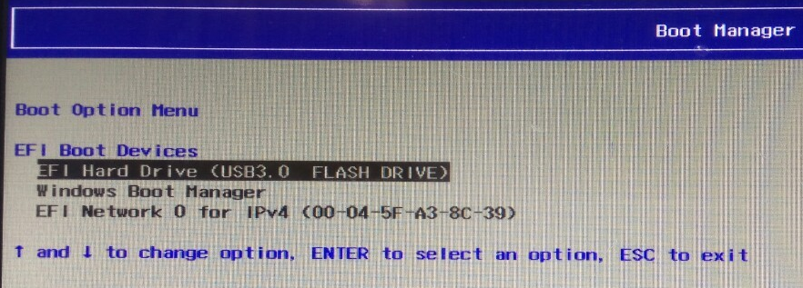

- Select Installation item.
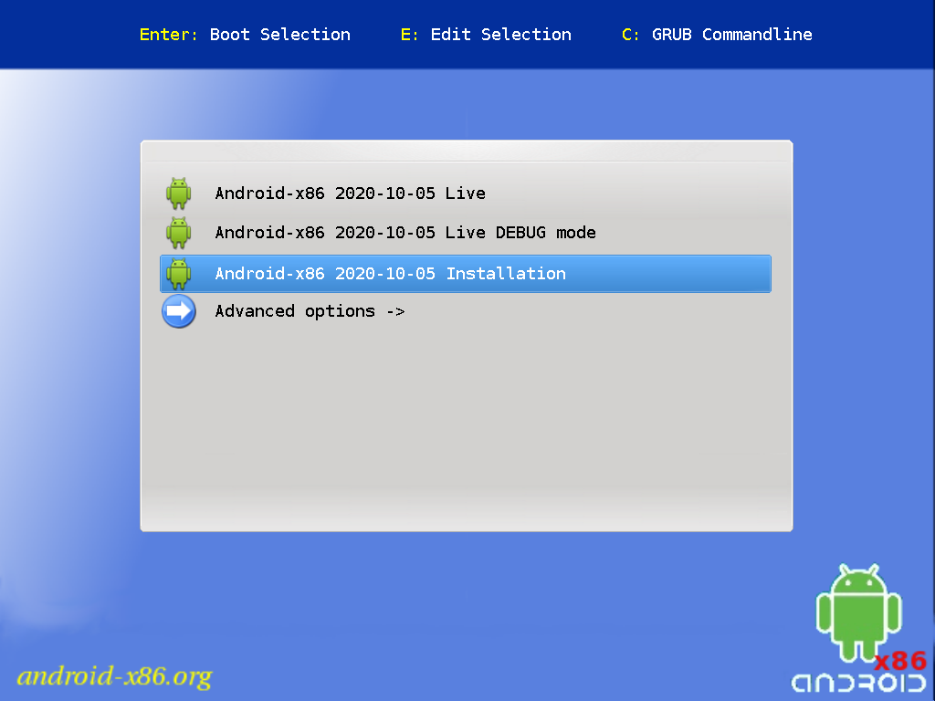
- Start image recovering process
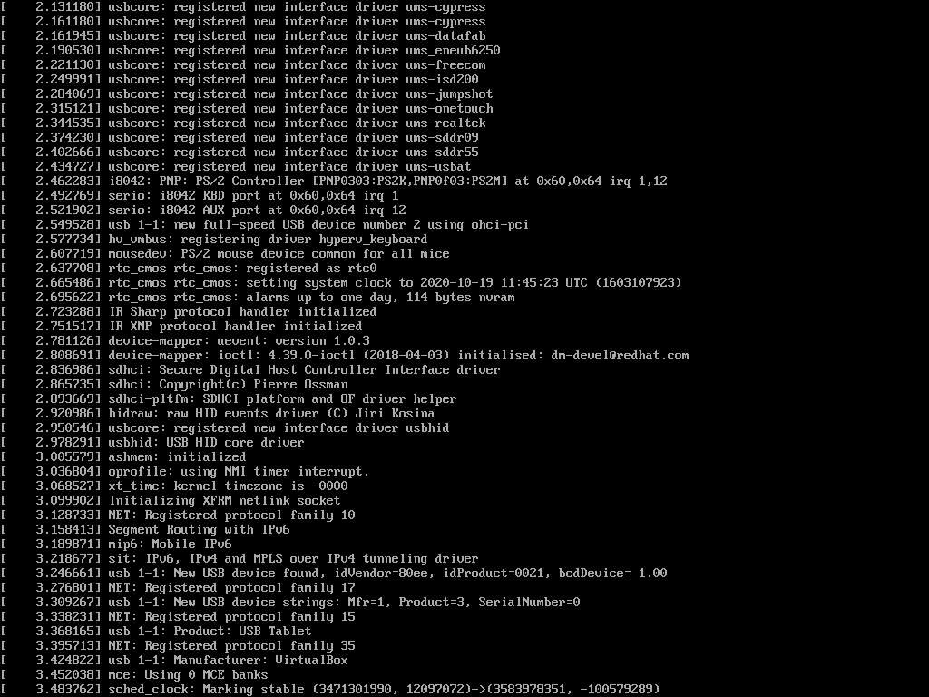
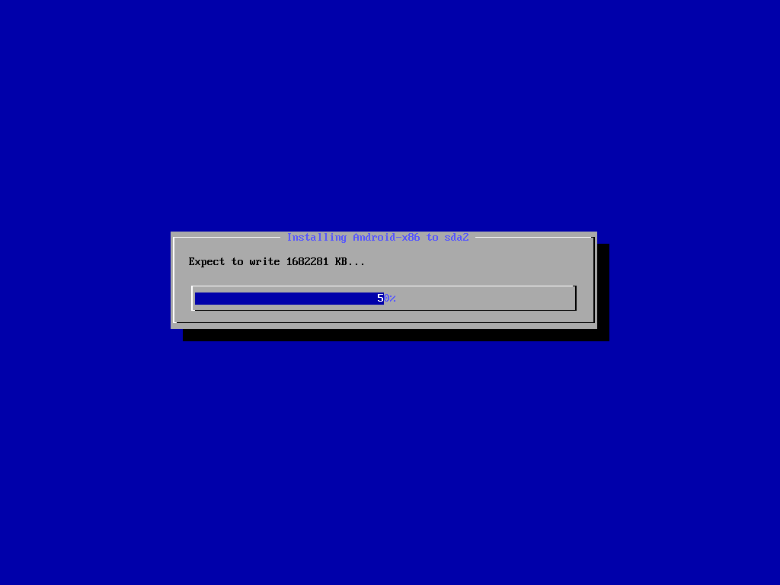
- When installation process is finished, press Enter to reboot.
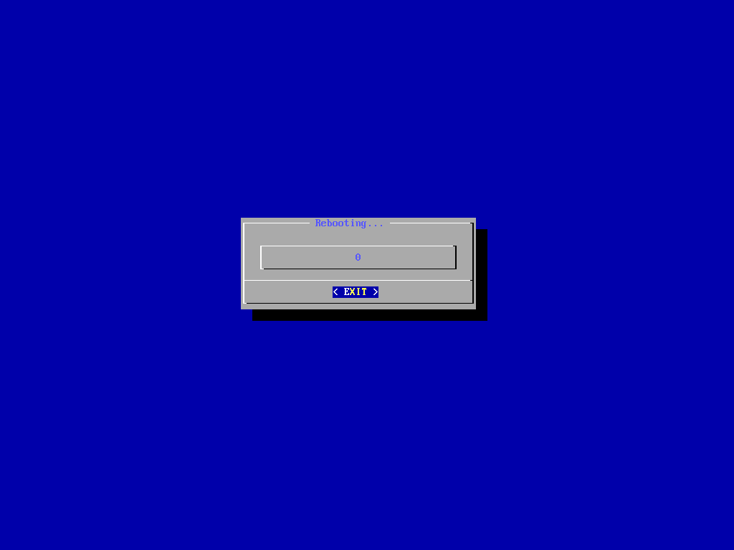

- Reboot and after boot into Android OS, it will show desktop screen.
